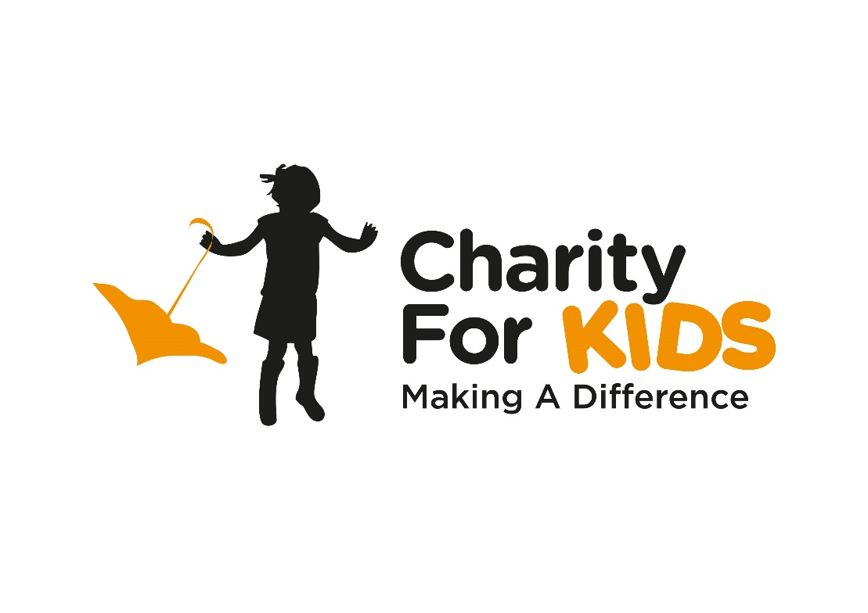
Charity for Kids Application Form
CONTACT DETAILS
Name of Applicant
Address
Postcode
Telephone
Email

ABOUT THE BENEFICIARY
Name of principal beneficiary
Date of birth
Please describe his/her condition -

What type of help do you need?

When do you need it?
Will anybody apart from the above named benefit from the proposed purchase/provision? If so, who and how?

Are you able to make a financial contribution towards the cost of this provision? If so, to what extent?
Is there anything else that you would like to tell us in support of this request?

Can we use any photos taken publically?
We will use your details to remain in contact with you about this application and also to let you know of other CFK events that you might like to take part in. Are you happy for us to use your details in this way? YES/NO

Signature ......................................................................... Date ...........................
FOR OFFICE USE
Successful YES/NO Case Number ....................................... Date Received .......................

Comments

Assessment Date ...........................................................

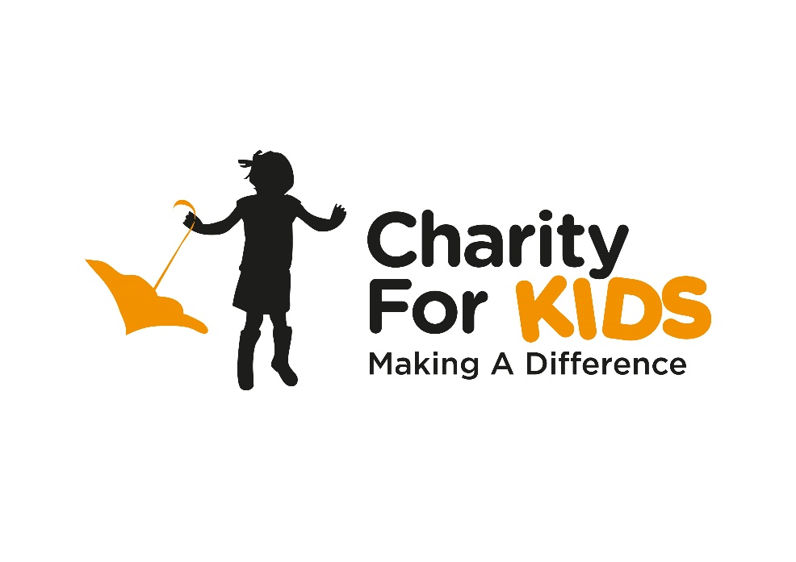
Guidance Notes for Applicants
Who are Charity for Kids?
Charity for Kids were formed in 2011 by a group of people who wanted to do something to help children with a terminal illness or a life-threatening condition. Members and supporters undertake a variety of fund-raising activities to enable the charity to provide facilities, equipment and services that will improve the quality of life of disabled children, and grant the wishes of terminally ill children.

Who does Charity for Kids support?
Charity for Kids supports children aged 18 and under in full time education, living in the Hastings & Rother District.
What will Charity for Kids pay for?
We will pay for (or contribute towards) the cost of facilities, equipment and services that will improve the quality of life of the child. We will often work with local companies and organisations who will provide materials and/or labour for free (or at cost) to enable our limited resources to stretch as far as possible and benefit more deserving children.
How do I apply for help?
An application may be made by the parents of a qualifying child, or by a friend, relation, or support worker (but always with the consent of the parents/guardians). Applications may be made at any time.

How are decisions made?
A Charity Committee meet monthly to discuss all requests received. In considering the merits of different applications, the committee will have regard for the following factors, in so far as they can be ascertained;
- The urgency of the request
- Value for money (i.e. the impact of the proposed measures in relation to the cost of providing the same)
- The circumstances of the family (preference may be given to families perceived by be suffering additionally from financial hardship)

Having agreed in principle to support an application, one or more representatives of the charity may visit the family in order to discuss the best way of offering support. Where funds are limited, this may involve examining alternative ways to achieve a desired aim, or making an offer of partial funding.

GUIDANCE NOTES
for the completion of the Charity for Kids Application Form
Contact Details
This section is self-explanatory. We may wish to contact you if clarification is required regarding any aspect of your request, or to arrange a visit to discuss an offer of support following the initial assessment.
About the Beneficiary
This section is all about the child for who support is requested. Please provide full name and date of birth.
Please describe his/her condition. Apart from naming the condition, please explain how it affects the child’s quality of life in terms of living with pain, lack of mobility, communication difficulties, inability to take part in activities with friends and peers etc.
What type of help do you need? Your request should not be something that a statutory body is under an obligation to provide, but will make a significant difference to the child’s quality of life. Please be honest and realistic when considering the difference between needs and wants, and consider whether there are alternative methods to achieve a desired benefit.
When do you need it? If there is a critical deadline, please explain why.
Will anybody apart from the above named benefit....? Any projects supported by Charity for Kids must be primarily for the benefit of the qualifying child, although the child’s family will frequently benefit indirectly in terms of reduction in stress or the sharing of some new benefit, or even as a result of modifications/improvements to a living space. Any such benefit must be an incidental result and not a primary aim of the request. Please list here any such collateral benefits, whether or not they are perceived to be material in nature, as this must be taken into account during the assessment process.
Are you able to make a financial contribution...? It is the wish of the Committee to support all deserving children, but where the demand outstrips resources, preference must be given to those families who are perceived to be less able to pay for support. However, having the ability to pay will not automatically exclude any applicant from consideration, so we merely ask for an honest statement of your situation.
Is there anything else...? Feel free to provide any other relevant information to help us to build a picture of your situation.
Are you currently affiliated, involved or funds being raised by any other Charities...? Please give details of other charities you may have had help from, or are currently involved with for fundraising etc.
Having completed the form please send it to the address shown below. All requests will be considered at the next panel meeting, and we will respond to all applicants.
All information will be treated in the strictest confidence, and stored securely in accordance with current data protection legislation. We will under no circumstances discuss your case with any third party without the written consent of the parents/guardians of the child.
Please be assured that Charity for Kids is not a remote and impersonal organisation. We care deeply about the children that we exist to help, and will do everything we can to have a positive impact. Our trustees, members and supporters have a common aim ... and we are determined to make a difference.

